**

**Subqueries**

**Inner Join**

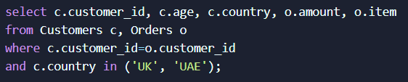

This query will return employees who have a matching DEPTNO in the DEPT table. Employees in departments not listed in DEPT or departments with no employees in EMP will not be included.

**Left Join**

For employees who have a matching DEPTNO in the DEPT table, their department name will be shown. If an employee has a DEPTNO that doesn't exist in the DEPT table, the DNAME column will be NULL for that employee.

**Right Join**

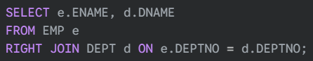

**Outer Join**

**Correlated Subqueries**

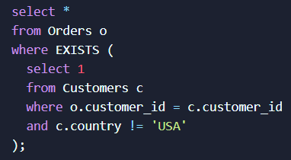

**Set Membership Search**

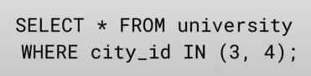

**Create Table**

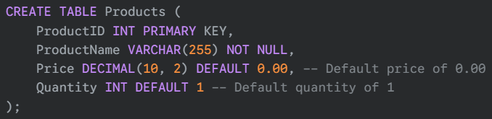

**Create With Conditional Logic**

**INSERT With Column List**



**INSERT Without Column List**



**INSERT With SELECT Statement**

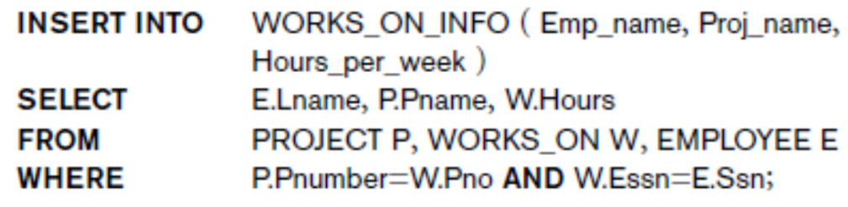

**Note:** The columns in the SELECT statement must match the data types and order of the columns in the INSERT INTO clause.

**Update All Rows**

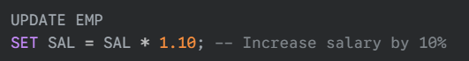

**Update Specific Rows**

**Update Multiple Columns**

**Delete All Rows**



**Delete Specific Rows**

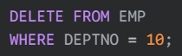

**Delete Rows Based on a Subquery**

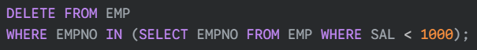

**Delete Rows From One Table Based on Another Table (Using EXISTS)**



**TRUNCATE TABLE vs. DELETE**

* DELETE removes rows one by one and logs each deletion. It can be rolled back within a transaction.
* TRUNCATE TABLE removes all rows quickly and does not log each deletion. It cannot be rolled back.
* 

**DROP TABLE**



**DROP DATABASE**



**DROP TABLE vs. TRUNCATE TABLE**

* **DROP TABLE** is a Data Definition Language (DDL) operation.
* Deletes the table structure (columns, constraints, indexes) along with the data.
* Logs each row deletion, making it slower than TRUNCATE.
* It can be rolled back within a transaction if the transaction is not committed.
* DROP is for removing the table itself.
* **TRUNCATE TABLE** is also a DDL operation.
* Removes all rows from a table, but the table structure remains intact.
* Minimal logging, making it very fast.
* It cannot be rolled back within a transaction.
* TRUNCATE is for emptying the table while keeping its structure.

**Adding a Column**



**Dropping a Column**

**Modifying a Column's Data Type**

**Adding a Primary Key Constraint**



**Adding a Foreign Key Constraint**



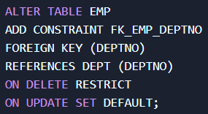

**Adding a Unique Constraint**

**Adding a Check Constraint**



**Dropping a Constraint**

**Updating a Constraint**

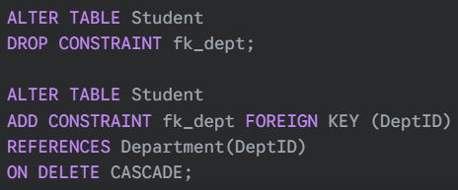

**Insert With Conditional Logic**

**Add Column With Conditional Logic**

